Sustainable development, ICT and Innovation AG1815

Authors: KTH Supervisor:

Joseph Newman, [jhnewman@kth.se](mailto:jhnewman@kth.se) [Anna Björklund](https://canvas.kth.se/courses/31368/users/4027)

Xiaoyu Wang, [xiaoywa@kth.se](mailto:xiaoywa@kth.se)

Vlad-Andrei Prodan, [vaprodan@kth.se](mailto:vaprodan@kth.se) External Supervisor:

Medo Almouhtadi, [almou@kth.se](mailto:almou@kth.se) Thomas Lindén

Tanveer Ahmed, [tanveera@kth.se](mailto:tanveera@kth.se)

SolidSport Study: How do we encourage climate-smart alternatives around sporting events. Minimising the Environmental Impact of Sports-related Travel in Sweden

February, 2022

# 

# 

# 

# 

# ABSTRACT

This study focuses on methods of minimising CO2 emissions caused by sports-related travel as per SolidSport’s sustainability goals. The solutions presented in this report implement the usage of ICT through the provision of emissions tracking tools together with user-friendly interfaces that encourage more social climate awareness and action among sports teams when it comes to their transport alternatives. The subject tackled in this paper aims to identify significant gaps in public awareness of the environmental impact of travel based on currently available data regarding noxious gas emissions caused by travel in Sweden, adding to a general carelessness surrounding the idea of pollution in the supposedly green Nordic country. In an attempt to solve this problem, this project report brings forth a user-friendly mobile application design meant to facilitate carpooling and a website that feeds into the competitive nature of sports players by comparing the degree to which they manage to reduce their carbon footprint through a relatable metric.

# 

# 

# 

# 

# 

# 

# TABLE OF CONTENTS

INTRODUCTION AND BACKGROUND ....................................................................................4

PURPOSE OF THE PROJECT .................................................................................................7

PROJECT DESIGN ..................................................................................................................8

RESULTS ...............................................................................................................................16

DISCUSSION AND CONCLUSIONS ......................................................................................24

REFERENCES …………………………………..………………………………………………………………........................29

# 

# 

# 

# 

# 

# 

# INTRODUCTION

Global sustainability discussions have been rising rapidly since the official definition of sustainable development in 1987 which was developed by the Brundtland Report.Global sustainability is defined according to the Brundtland report as “meeting the needs of the present without compromising the ability of future generations to meet their own needs.”[X1] Humanity has come to realise the importance of sustainable development due to the effects of global warming and the climate changes worldwide. In 2015 the United Nations members created an agenda called “The 2030 Agenda for Sustainable Development” which is to be adopted by all UN members. The agenda at its heart is defined by the 17 Sustainable Development Goals (SDGs). The objective is to produce a set of universal goals that meet the urgent environmental, political and economic challenges that face our world. [X3]  
  
   
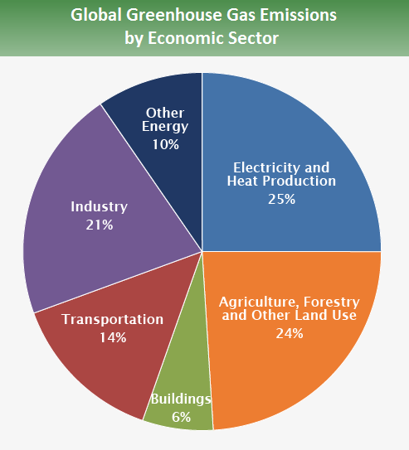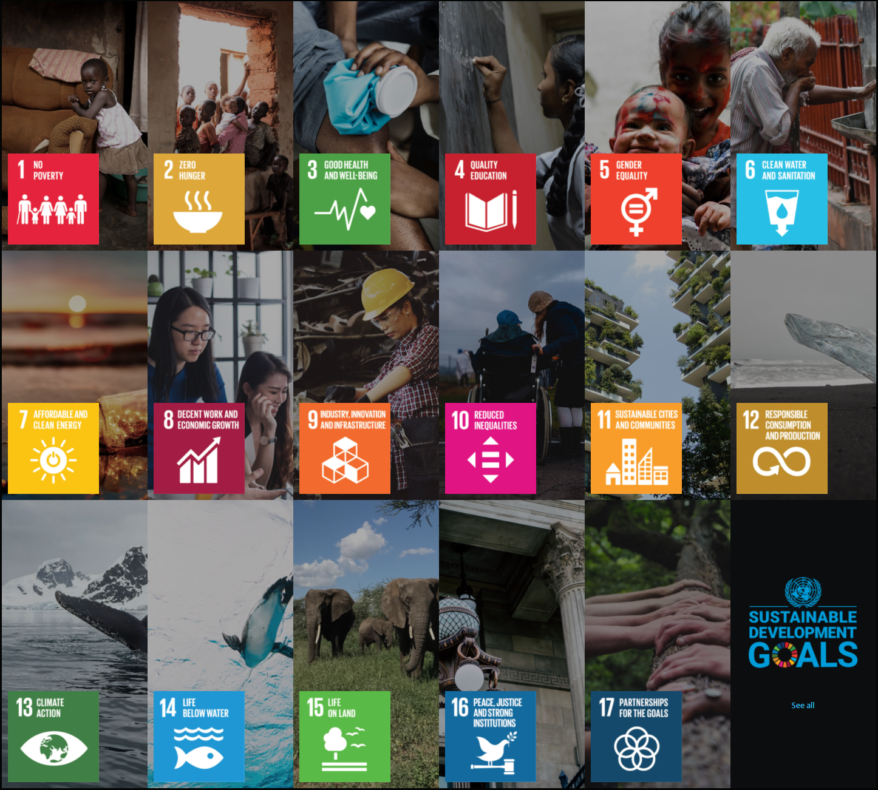

The transport sector is currently the source of 14% of global CO2 emissions [J2]. It is thus a major contributing factor in environmental impact. As such it must be addressed since it plays such a large role and collective global sustainability solutions must feature it. Since there are multiple modes of transport and huge variations from nation to nation, a variety of smaller, detailed and applied solutions is likely to be what is required in dealing with this effectively.

As Jonas Åkerman presents in his finding on the environmental impacts of the transport sector in Sweden: Technological advances including the development of more energy-efficient or alternatively fuelled vehicles, as well as, increasing production of renewable biofuels are part of the solution. However, if Sweden is to reach its 2050 climate goals of limiting global warming then limiting/reducing the volume of traffic(of all types, including cars) is needed [J1]. Simply put, a key part of the solution of sustainable transport is reducing traffic.

The climate impact of transportation-related to sporting events is also the subject of concern in the industry, as people from all over the world travel to different locations in order to support their teams. This is especially prevalent in Sweden, where sports fans often choose to use their own cars to reach the stadium where the event is held. In fact, statistics show that for the 2017 UEFA Europa League Final, 54% of supporters in Sweden travelled by car, while 12% of them travelled by aeroplane while 34% used public transport methods. [1] Seeing how the majority of supporters travel by their personal car, this behaviour renders unnecessary pollution, correlated with the relatively small percentage or aeroplane users, which on paper may seem insignificant, but represents huge emissions in practice. This data may not be representative for all sporting events but it’s a figure that proves the relevance of the climate impact caused by sports-related travel.

From a sustainability perspective, it is of utmost importance to note that travel as a whole sector and its corresponding environmental impact is the sum of many small parts- or rather, it’s composed of the travel of many individuals. One example of this applied is as follows. According to calculations made in this research, estimating the CO2 emissions of a small urban league in Sweden, if all players were to travel to the event they play at with their own car, this would amount to the same emissions caused by charging 669,035 smartphones.[2] Even in a simple, small scale example, clearly, the sum of many parts adds up.

Furthermore, each week thousands of Swedes (& millions globally) take themselves or their kids to play sports. The environmental impact of this is seldom considered but the sum of many individual impacts is surely not insignificant. In this report, we will be investigating this impact and seeking to find solutions to help find climate-smart travel alternatives to help mitigate these negative environmental consequences.

In terms of information and communication technology, the problem posed- how do we encourage climate smart alternatives- relates heavily to alternative and more climate-friendly methods of transportation, as well as to the usage of software elements such as mobile applications or websites to create virtual environments that can encourage more climate consciousness among the users.

This report will be looking at the problem broken down into 3 key aspects. Namely, what is the current impact? Researching and gathering information to make an estimate on the current state of transport. Further, How can this be used to in an informative way encourage people to take climate-smart alternatives. And in combination with both of these aspects how can these alternatives be facilitated and how can this be measured to analyse the effectiveness of such implementations.

# PURPOSE AND AIMS OF THE PROJECT

There are two perspectives on the purpose of this project:

Organizationally from SolidSport, the focus of this research is, “How can SolidSport strengthen its brand as a player that, in addition to broadcasting sports live and thereby reducing the amount of travel to and from events, also pushes people to choose climate-smart transport alternatives to and from events? “

Within the project group, the purpose and focus of the project are: Firstly to help answer the question which SolidSport have raised and aim to provide creative solutions and ideas which they may wish to use. Furthermore, in connection with this, it is to creatively apply the knowledge that we have learned regarding sustainability combined with ICT technology to find ways that can help SolidSport and its users make a positive impact on the environment by minimising CO2 emissions in connection with travel to sports fixtures.

In particular, the group’s purpose and aims are that solutions should be:

* Significant in that they facilitate sustainable choices and also
* Measurable since a quality solution should withstand analysis and evaluation
* Applicable and useful to SolidSport,
* Realistic & Relatable in that they are user friendly and something people would actually use
* Transparent in that all data and research used is sourced and presented carefully

Solutions presented in the report will be anchored into this framework.

As mentioned in into- seek to find information, inform/encourage and facilitate…

Delimitations & Scope

*<What we are and are not going/trying to do…>*

Due to practical factors, market research and athlete questionnaires will not be conducted for this project. （More?)

# PROJECT DESIGN & METHODS

Overview

The group decided on a three-part solution, a broad response to a broad and complex problem. It was observed that there are three key areas to handle:  
   
1. Calculating environmental impact in connection with travel. Subsequently informing and encouraging smart travel alternatives  
2. Facilitation of smart alternatives  
3. Website and integration of proposed solutions.  
  
In this section, these three parts will be presented together with how the work on developing them was planned and carried out.

In line with the three distinct parts of the solution, there is a website as an extension and combination of research results and app. This provides information about this project and helps encourage smart travel alternatives. It also provides links to tools developed to facilitate and measure smart travel and in this way serves as an interface for users. The website is open for both players and audiences. Users can get visualised results about CO2 emissions reduction from each team and each player. (More detail on Method:website)

3.1 Information

One task identified was to research the environmental impact of travel in connection to sporting events. The aim was to subsequently produce a number of statistics which could be used as a basis to inform and encourage people to take smart travel alternatives.

Research was conducted to find accurate and updated values for average vehicle emissions in Sweden. Different ideas of models to calculate these emissions were presented and discussed. The finalised equation used to calculate emissions is as follows:

Emissions from participants of a sports event = E*D*(N-P)/ (S)

Where variables are as follows

| E = | Average Swedish vehicle emissions/Km(In Kg) |
| --- | --- |
| D = | Distance to travel from home-away stadium |
| N = | Number of players/team |
| P = | Number of players using Public Transport |
| S = | Number of players/Car |

In order to calculate large numbers of emissions, this model was applied on various existing handball leagues in differing locations in Sweden to see how the results varied and to help us come to a reasonable estimate. The value from the equation above would be multiplied by the number of matches per league, as well as, by the average distance travelled per match.

In order to calculate, Data was collected from the official Swedish handball(Svenska Handbollförbundet) website and 3 leagues were chosen at random and used as a basis to generate travel distance data for the research [reference leagues].

Key aims during this work were:

* To produce a number of useful statistics for use on this project and for SolidSport should they wish to in future initiatives
  + These Statistics could be presented in a positive way that would help potential readers/sportspeople to be encouraged into taking climate-smart alternatives
  + These statistics should be relatable/ framed in an understandable context for sportspeople of all ages including children
* To use reliable sources of information and where possible to verify information
* To work transparently so that all our sources of information are accessible and all the steps taken and assumptions made in calculations/estimations are presented.

The following data was researched and used in the calculations.

* The amount of CO2 emissions produced by a passenger car can be averaged at roughly 93g/km according to new data from the European Automobile Manufacturers’ Association [3] , backed by research from Trafikverket [4] , while for a bus, it would account for 14g per passenger-kilometre. [5][6]

And the following assumptions were made in order to calculate an emissions estimate:

* The distance between each team’s home locations is travelled 4 times, for the home and away games, including the return trips.
* A team would consist of about 20 people including the coach and reserves and we assume each person uses their own car in order to showcase the worst possible scenario of emissions.

The second part of the solution is to create an application to have users calculate their emissions connected to their sporting events to incentivise them to use greener transportation methods. Research was conducted to investigate relevant API’s and other similar applications in the market. (This is what has been done so far?)

3.2 Facilitation

Facilitation of smart alternatives is handled in this project with the creation of an application that allows users to, carshare, collect data to measure the environmental impact of transport and seeks to inform/encourage smart alternatives.

The application design has been developed in accordance with the variables that directly affect PEOU (Perceived Ease of Use) [7] and with the technology acceptance model (TAM) principles. [8] Research specifically tying these subjects to sustainability labels and their importance as part of consumers’ experience has shown that similarly to products that are not related to this subject, simplicity is one of, if not the most important feature in the success of the implementation. Correlating this to the previously defined “SMART” goals of this study, the choice of format for the application is meant to support the relatability of the solution by offering a user-friendly design where the functionality is clear and easy.

An application design aimed at facilitating the use of smart alternatives is as follows. The key features allow users to post that they are driving to an event and have spaces in their car. Subsequently other users can opt to carshare. An application layout could possibly have the following implemented features:

Design to support joining and creating carpooling events. When a user decides to join an event they are directed to a map where they enter the destination of their event. Upon selecting a destination the user is presented with the closest rides that are available to that destination and the user can then reserve a spot on that ride. They are then provided the necessary contact information and a chat function to contact the ride organiser. If the user proceeds to attend the event with this method they are then awarded points that they can collect to display on their user profile.

If the user decides to create a ride they are asked to provide some information about their travels. The name of the event, departure address, destination address, vehicle type and maximum number of passengers. After creating a ride they can publish the event to be viewed by other members of the sports league. If a different user decides to join the event they are then connected and presented with their contact information and chat function. Upon completing the event they are also awarded with points that they can collect.

Application Features:

* 3 main UIs:
  + Default transportation method.
  + Create an improved ride method:
    - Choose transport type (options - Train, car or bus):
      * Select start location by entering an address or tapping on the map.
      * Select event destination (displayed as a list of events available)
      * (If car option chosen) then provide an additional entry field:
        + Choose energy type usage for the car: Electric, CNG, Diesel, Petrol or LPG car
      * Provide driver departure time.
  + Join an improved ride method:
    - Show available rides nearby (via a map): Tapping on a ride provides options to join along.

Application features:

* Statistics screen:
  + Example: How many trees you saved over time while transporting
* Discounted coupons are provided upon arrival to destination:
  + Aquire points by completing improved rides:
    - More points with more passengers
    - Points can be redeemed for coupons.
    - Points are collected and compared to other actors that are also using the system.

The application prototype was developed using a website called Figma. Figma is a collaborative software prototyping tool that was picked due to its popularity among the team; it provides real-time sharing of individual prototyping behaviours among team members for collaboration. Starting off, the first core screens were created. A StartScreen, JoinEventScreen and a CreateEventScreen. These screens were designed to have a few buttons and textfields and input forms. The Figma prototype elements can easily be integrated via importing objects like images, tables, software templates, maps, UI abilities, etc. The ability to import finished components, plugins and templates is a highly practical and quick testing tool to design an application before it’s programming phase. For instance there is a Google Maps plugin that was used to display the map when you enter addresses. Furthermore, these components can be edited to suit every user's needs and therefore speed up the designing process.

In order to implement a usable design, certain UX design elements are considered:

The prototype being built is aimed at incentivising consumers to use available features in order to both save the environment as well as gather redeemable points for a price. While all this is happening, the application should collect statistical data on how much each user is contributing to the environment. The application to incentivise consumers to travel together is developed in a low-fidelity prototype at first to ensure all the core functionalities are being implemented.

The point collection is a feature that is supposed to incentivize the users to travel more environmentally conscious. These points will additionally be collected and then shown in a score tracker for the whole sports league to encourage the whole league to compete on who gets the highest score.

Points collection also means being able to redeem prizes. Those prizes can range from event items, discount coupons or any other prizes that Solidsport finds fit. Planned points conversion can be like the following:

1. Car sharing:
   * Driver and 2 passengers: Rewards everyone with 1 point
   * Driver and 3+ passengers: Rewards everyone with 2 points
2. Train/bus travel (with any number of passengers): Rewards individual with 2 points

The choices above are out of intuition of what could attract the most number of consumers on the app. To further evaluate a better conversion system, Solidsport should get user feedback and observe user behaviour over time, this is in order to maximise the number of users willing to take better travel alternatives. The conversion between points and prizes is up to the business to update regularly over time in order to also maximise app usability.

Application programming interface (API) is a software-software way of communicating. In order to best implement the backend mechanics of the application APIs were highly considered as they are able to maintain correct energy-to-CO2 conversions together with our ever changing worldly factors. They are becoming increasingly more convenient for programmers and businesses due to ease of usability and integration. They usually come at no cost and provide real-time data sharing between servers and softwares. Rather than build an entire application service from scratch, using APIs enables blocks of functionalities to be integrated with minimal efforts. Some concerns with APIs are related to security, adding additional dependencies between the application and the resulting output at the customer end could raise concerns. For example, nesting multiple API services could result in a failing functionality if one dependency delays or fails. Furthermore, APIs provide additional layers that a hacker could attack and take advantage of. Generally, business leaders attempt to minimise dependency on cloud services, especially if unreliable.

With an unsustainable API comes unsustainable software. As the library for both private and open-sourced APIs increase, competition greatly increases. As a result, one should expect “greener” APIs being built with refined backend structures and models that take into account energy use and self-sustainability. With the intent of “advancing sustainability, environmental awareness, or specific climate action initiatives”[M1] <https://nordicapis.com/green-apis-promote-sustainability-and-climate-action/> we will be able to create a future with more sustainable API technologies. What is better than an environmentally sustainable API that provides data about carbon footprint and sustainability? APIs generally aren’t the most scalable but with increasingly emerging B2B API services, they are increasingly becoming more scalable and environmentally sustainable.

3.3 Extension Method: Website

Another prototype developed is a website connecting our research result and application. The target group for this website are both players and spectators.

The aim of the website is to visualise data and encourage people to adopt more climate-smart behaviours in traffic. In this web page, we provide players with calculation models, players can figure out how much carbon emissions are reduced by environmental protection behaviour, and don't forget that as a public figure, their decisions affect more people's attention to environmental protection and climate change. The audience can follow the game through our streaming media, and it is also a platform for them to support their favourite environmental sports stars.

There are two parts to attract users to participate in our climate-smart traffic reduction plan via this web page.

Step1, we update the current game information and cooperate with Solid Sport, thus our user can reach the game news and related stream through our website. This will make sure our audience can get certain valuable game related input.

Step2, combined with our app, allows the player to try to find a partner on the same way to share the traffic and record how much CO2 emissions they saved in the meantime. By sharing the same user account, their CO2 emissions data will also be recorded on the webpage, and also merge with the team they are working in. All users are able to see how much contribution they did for a certain goal. While competing in sports, we also want to call for environmental protection through this method of reducing carbon emissions more.

We will achieve these two steps by six main pages: Home, Model, Goals, Starts, Agenda and news with a user account system.



Home: We will provide the company logo, project introduction, aim and slogan on the Home page.

Model: We will provide API based on the result of research about CO2 emissions calculations.

Goals: In the form of a competition, we will propose an emission reduction target for the two teams participating in the competition and dynamically visualise the results.

Stars: We will list athletes who have recently achieved outstanding personal emission reduction performance.

Agenda: In the form of a sport game event calendar, this page will provide information of the latest game and time.

News: We will post some sport game related blog or report on this page.

The construction of the website will be based on the Wix online tool. The pictures used are all from the Wix image library. The names of athletes and sports events included are fictitious.

# RESULTS

This project offers several alternatives to the traditional transport choices, by incentivising car sharing, offering insight on the gravity of the problem to SolidSport customers and other sports enthusiasts, thus resulting in a behavioural change that can benefit both the climate and the image of the company. As previously described, the problem was broken down into parts, the results will also be presented in this way.

4.1 Information

Three different handball leagues in Sweden have been thoroughly analysed in terms of carbon emissions caused by the travel between the teams’ home locations. In order to gather relevant information, we chose to include 2 leagues based in urban areas, namely Stockholm and Gothenburg and 1 league in the sparsely inhabited north, where distances between teams are rather large. On this note, the results reached are the following:

* for F14 Norr [Handball league 3], the total distance travelled by the 18 teams that comprise it reaches the respectable number of 197,356 km, with an average distance of 625 km per game
* for F13 Väst 3 Södra [Handball league 2], the total distance travelled by the 7 teams in the league reaches 3,003 km, with an average distance of 71 km per game
* for F15 Nivå 1 Öst [Handball league 1], the total distance travelled stands at 10,182 km, with an average distance of 113 km per game

For the league analysed in Gothenburg( F13 Väst 3 Södra), calculations show that the total carbon emissions can be quantified at 5,585 kg when no carpooling is used. This is equivalent to producing 4504 kg of pasta or flying 10 transatlantic flights from London to New York. <or other relevant stat>

<stats produced: bowls of pasta(perhaps the energy gained by eating x bowls…), transatlic flight emissions, presonal co2 budget… smartphones/ power for a house… some of these we still need to finish making>

4.2 App

Climatiq’s API options and features will provide the elements that are required to build the application prototype. Out of Climatiq competitors, none show long-term promise. They could be unreliable with expected failure to update with accurate on demand data. With promising growth of Climatiq and it’s recent 2 million dollars funding, despite its founding date being in 2021, it’s becoming increasingly more reliable. With continuous growth of climatiq’s scientific-based database size and reliability, a programmer and a business person can both save loads of time. This could either be because one would incorporate less layered APIs, or read little to no papers in evaluating CO2 emission estimations. Climatiq further offers a large sum of clear API documentations that specify use cases for quicker implementations. Integration could occur on any device running the application or any server located at data centres of one’s choice.

Integrating Climatiq in SolidSport’s applications would enable the desired features to work like intended, with its ability to quickly query region based data centres, one should expect a quicker and more accurate estimation of the activity in concern. Being able to access the continuously updated Swedish environmental database centres is a powerful tool that would save SolidSport immense time and energy since it does most of the calculations and returns hours of research in less than a second.

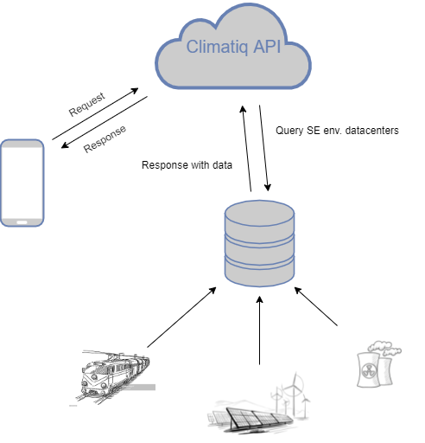

Image I: shows the connectivity among consumers, Climatiq’s API and data centres.

By applying Climatiq’s API services, transportation methods can be identified using the application and accordingly calculated using the API features. Transportation methods like trains, petrol and electrical vehicles can all be identified and quantified effectively.

To calculate train carbon emissions in Sweden we assume average train load within the 24 hours period. This was calculated to be around 500,000 Joules per person per km, by the help of a Master’s thesis student’s research on carbon emissions of public transportation in Sweden[7]. In order to estimate carbon emissions, Climatiq provides a database of updated conversions from Sweden electricity Grid mix into carbon dioxide emissions. With an API request, parameters including the 500k Joules per person per km and the travel distance in km need to be inserted and sent to the correct url.

From the API response, useful information like gas emission quantity, units and other gases at play (CH4/N2O) can also be considered when evaluating user based statistics and in quantifying environmental contributions.

There are currently no databases for fuel based vehicles in Sweden. By considering other database locations (like the United Kingdom), they can be suitable for vehicle footprints for Sweden. This is due to the averaging for each car energy type (CNG, Diesel, Petrol or LPG cars). This works by sending an API request with parameters that include the number of passengers over the computed distance to the sports event. Google Maps API or similar can be used to quickly estimate those distances.

To estimate CO2 emissions of an electrical vehicle on a one way car ride, take the average electrical consumption of electrical vehicles and the distance it is going to travel, we get a number with a unit kWh/km. The API accesses Sweden’s database centre to calculate grid mix to CO2 emissions conversions, which provides us with an accurate amount of carbon emissions per energy unit (kg-CO2e/kWh). In this way if we multiply both variables, we can get the amount of CO2 emissions per unit distance kg-CO2e/km for an electrical vehicle. If a higher accuracy is desired then one can take the extra mile of asking the consumers on the application on which, for example, Tesla model they are using. If we then map all Tesla models to their corresponding (kWh/km), then a better accuracy is achieved.

Research has shown that incentivizing carpooling for teams travelling to sporting events can reduce noxious gases emissions by sizable figures.

(write more stuff about the data and improvements that can be achieved with this solution)

4.3 Website

In the frontal page, we introduced the value, field and purpose of our project.

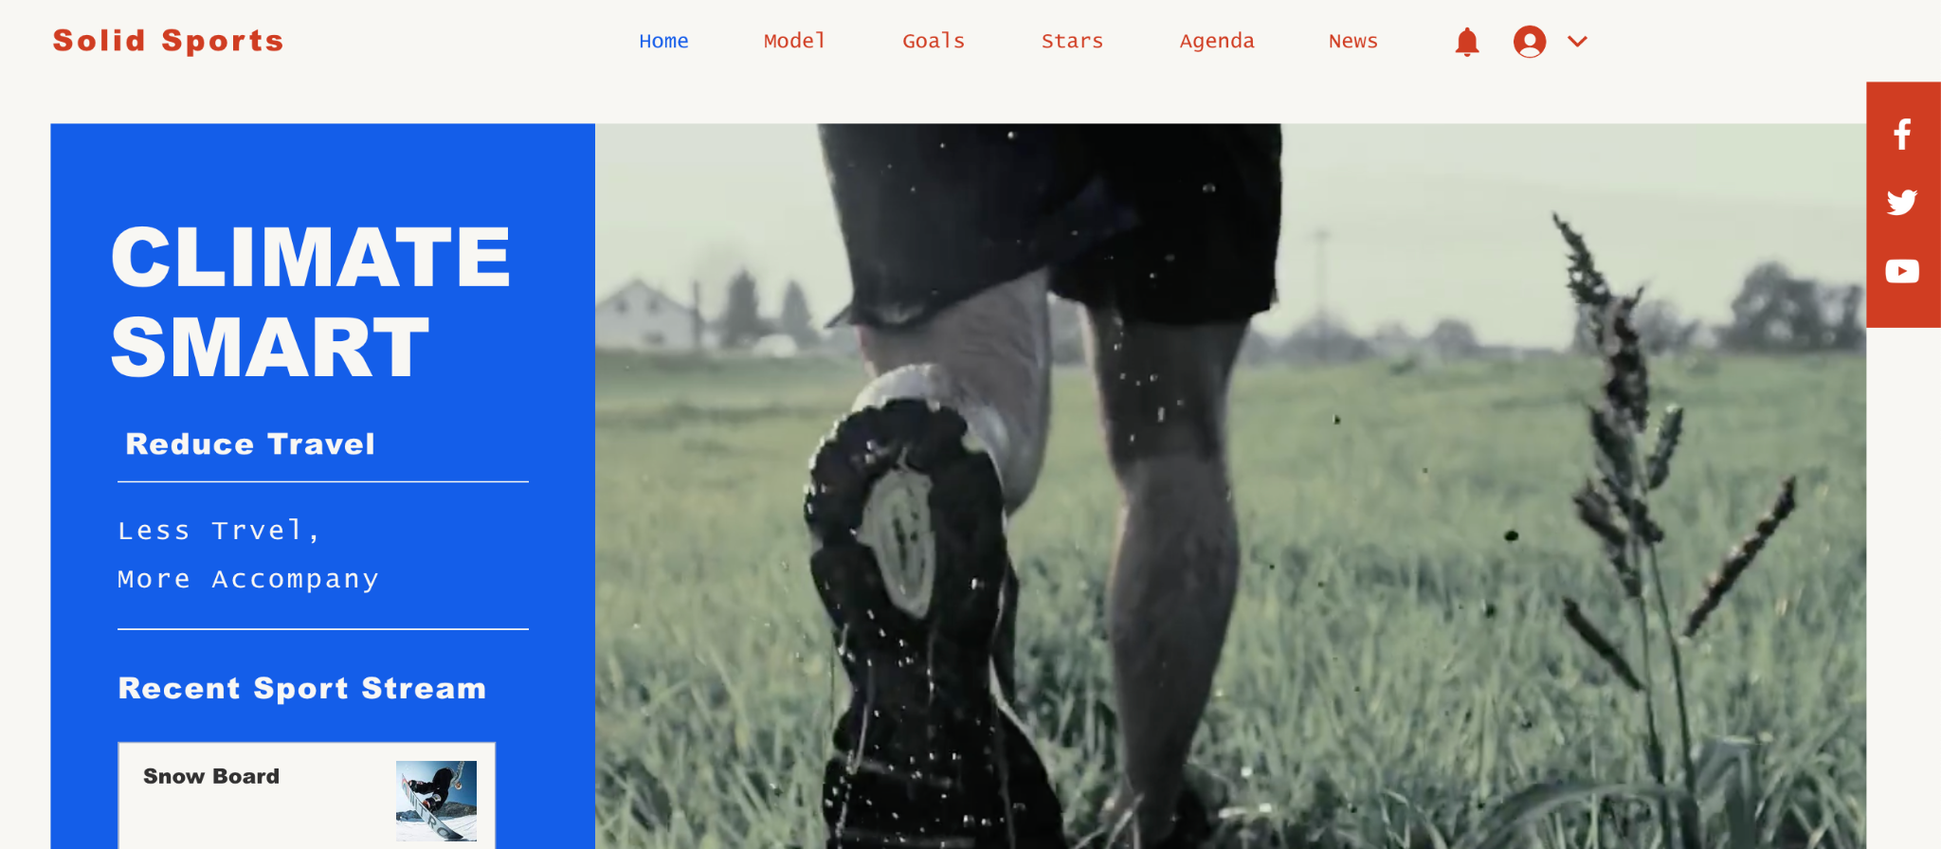

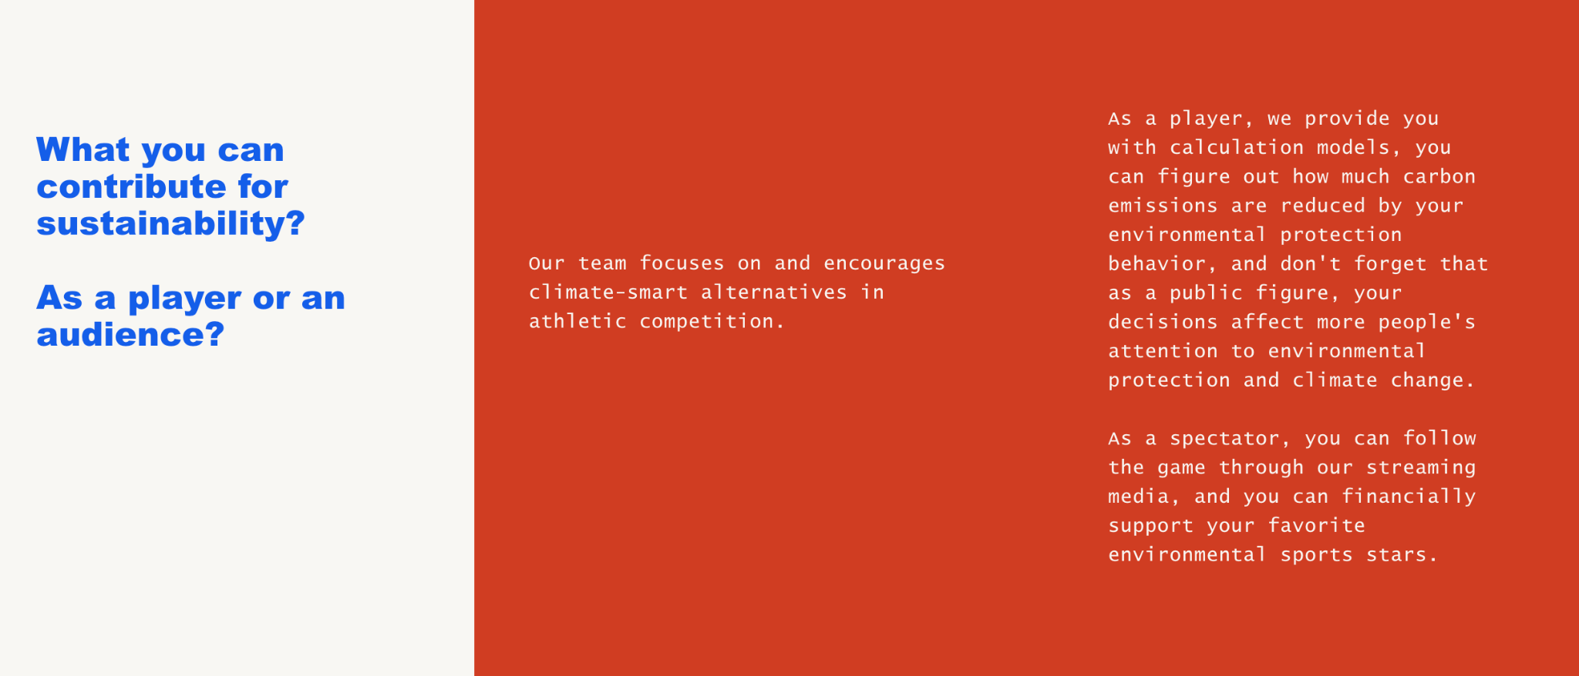

In ‘Our goal’ page, we also transfer the carbon emissions into glacier melting, deforestation and other projects with our model, because climate issues are closely related to our living environment and the global environment.

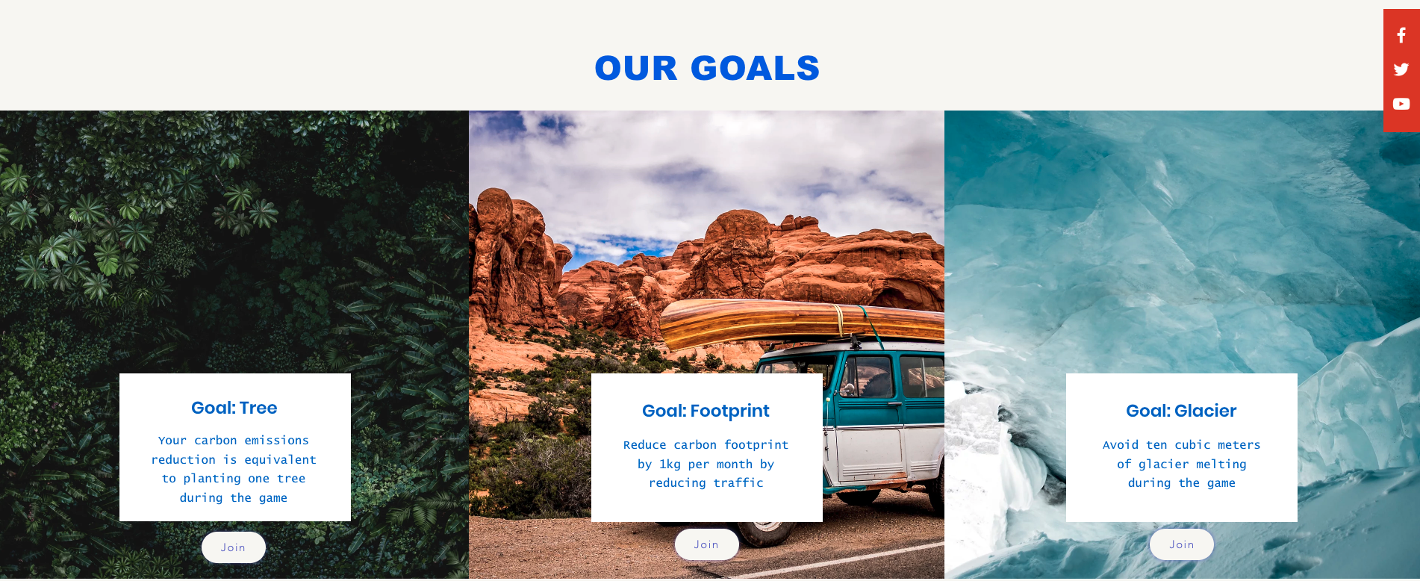



Inside each goal, the user is able to see the current two competing teams within one game. We provide tables and graphs to visualise the result of CO2 emissions. By comparing the data of two teams, it will be easy for users to know the progress of the competition of CO2 .

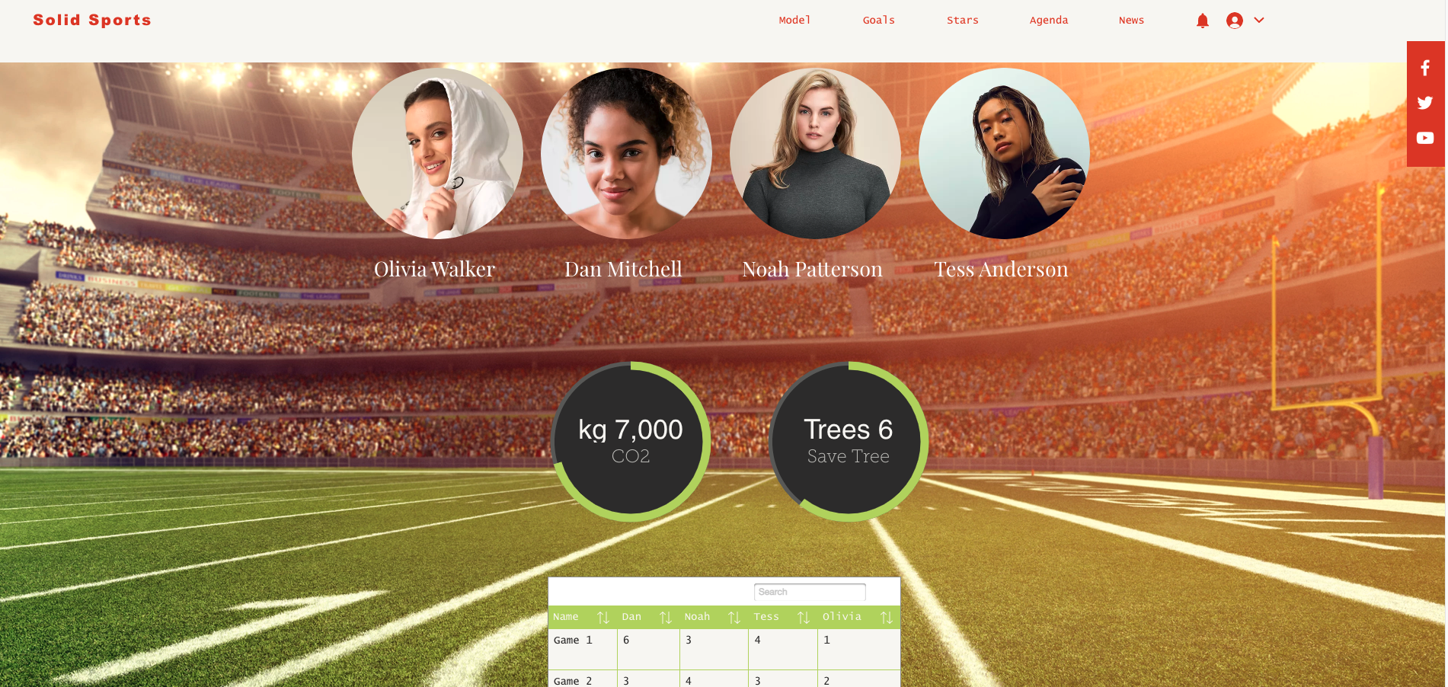

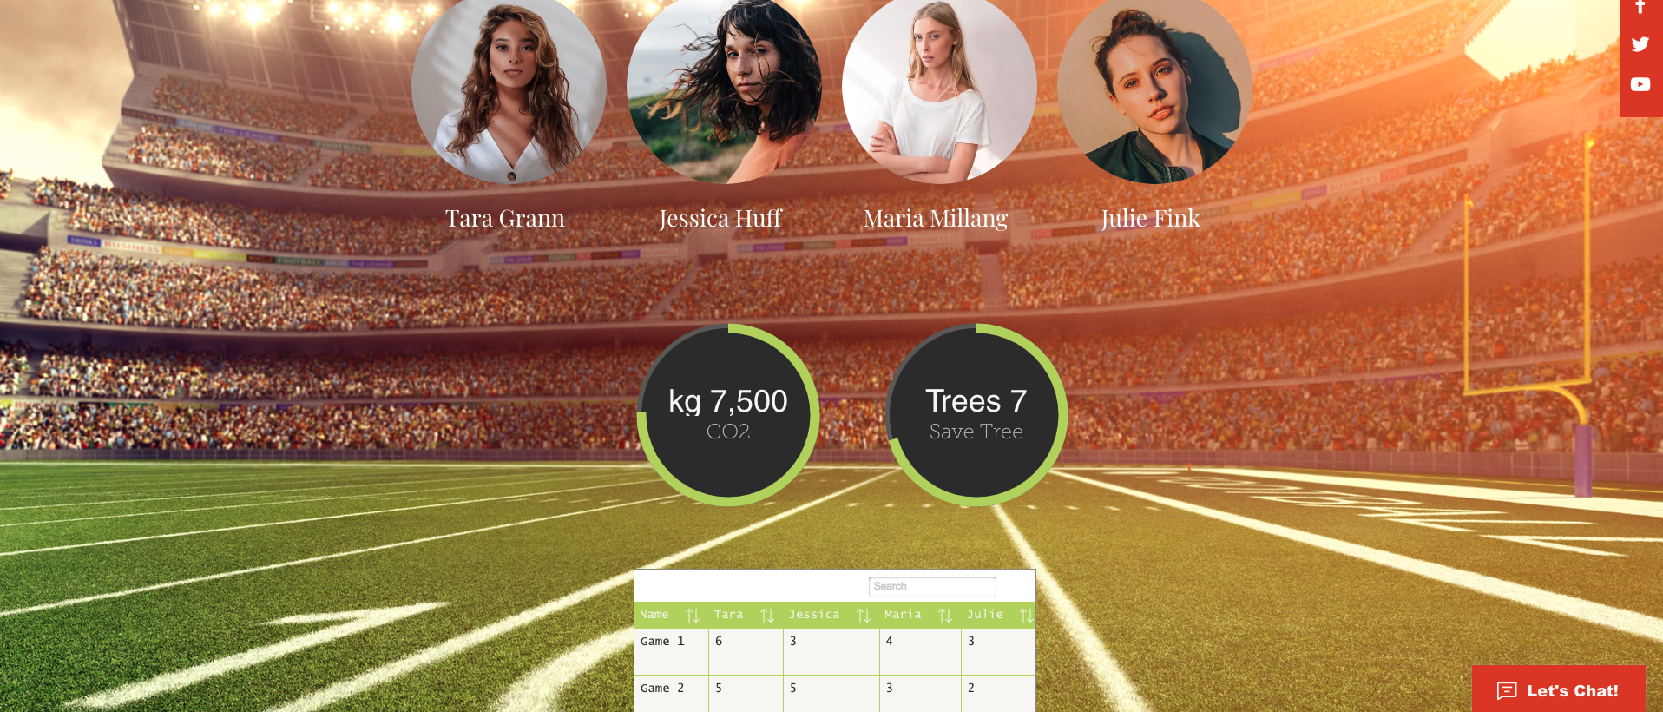

On the ‘Model page’ we will provide our calculation method from our research part here depending on different types of vehicles.



On the ‘Agenda’ page, the user is able to get the current game information.



We certainly welcome more companies that want to contribute to environmental climate issues to join us, and we will showcase these companies on the 'Partners' page.



On the ‘News’ page, users will be able to read sport related blogs or news and comment their opinions below.



# DISCUSSION AND CONCLUSIONS

To ensure that a larger portion of consumers also use the car sharing feature, the application design must be very simplistic and easy to use. This avoids overwhelming users on how the process of registering or joining in-application transportations works, which could result in users abandoning the feature or not using it in the first place. Application designs play a lot of role in determining if a user will access the app’s features. Limiting the number of choices the user needs to go through also shortens the time spent on the application and makes the process go smoother. Furthermore, the choice of APIs is what determines if your application will function effectively with accurate real-time data or not. Combining both a good design and with an integrated API, the application is likely to get increasingly more popular, creating a cleaner environment along the way.

Alternative Application designs can be considered. However, to understand each design’s effectiveness on the user, the design needs to be quickly tested in the hands of real consumers. This would give a greater insight on which application design has greater advantage in what. The alternatives could look like the following:

1. Simplistic design: An application that only deals with car sharing, no options on bus/train transportation methods. Also no option to choose between petrol or electric cars. Simple vehicle sharing and rewarding.
   1. Cons: Statistical data is inaccurate but maybe still satisfies the user?
   2. Pros: Very easy and cheap for SoldSport to implement. Simplistic design and ease of usability could attract a larger portion of consumers on the app.
2. Current design: Choices between fuel type, car, train and bus (Most options are considered).
   1. Cons: Harder to implement, could overwhelm users.
   2. Pros: More logical in terms of transportation use options and statistical accuracy
3. Advanced design: Platform based design with chat systems, inviting nearby users to join events (revenue buff and save environment), more complex vehicle model-to-model selection with a more accurate statistical data displayed.
   1. Cons: Adding complexity could further overwhelm users. With complexity, the application is likely to get more loyal customers rather than quick customers.
   2. Pros: Full option transportation methods display an enhanced statistics accuracy. The chat system can make it easier for drivers and passengers to be in

The advanced option above could include more features of course. To understand which advanced features should be integrated with the current design, further user feedback is necessary to better understand the mind of the consumer. Due to the limitations of this report, the conclusion is that further user research is required in determining which features make the most sense in the hands of real users. With extended user feedback, one can also comprehend the user’s expectation on the statistics accuracy. A better understanding on the balance between feature simplicity and advanced options would maximise user traffic while minimising the negative environmental effects related to sport events.

In this section we will add Ethical & social considerations. These will be brief and to raise potential issues/concerns/thoughts that SolidSport may want to consider or should keep in mind in future implementations or when developing sustainable solutions in this area. Examples of this could be: safety issues with car sharing… and others. Is it fair if one person always drives and others get lift, economic issues such as who pays for fuel… (obviously this needs developing further!)

We shall also bring up relevant area’s of theory and existing research related to our topic. These may include- Hilty, something from the transport lecture, rockstrom, the introduction lectures talking about emissions and climate issues etc

Bring up solutions which we thought of but chose not to develop- they may still be of use to SolidSport.

We may also wish to raise creative incentive suggestions here as well as behavioural theory & patterns to motivate this. Ideas we’ve had include- tokens for snacks, equipment for teams, even towards a bus. Reduced fees for watching on solidsport, prizes for winning the green league…

Following Lorenz Hilty’s framework [V1] for quantifying the effects of ICT and sustainability, the solution described in this report can be analysed on the three levels of impact as follows:

Level 1: In terms of “life cycle impacts”, the cost of providing the internet-based services that facilitate carpooling is represented by the use of energy and resources needed to run them. The devices used to render the application are contributors to pollution simply by their own existence and eventual need of disposal and the electricity required to charge these devices may be acquired from toxic sources.

Level 2: Looking at the “enabling impacts” of the solution, the following aspects are of note:

* The “induction effect” is characterised by the intensification of consumption resulting from the usage of the ICT product; in this case, the API used requires server space, which may consume enormous amounts of electricity, tying into the aforementioned battery charging needs from level 1.
* The solution might not be able to render any tangible resource obsolete, but it can offer a substitution to the traditional way players use to arrive at the event: that of using their own car.
* The optimization offered by this solution relates heavily to the minimisation of the number of cars used to travel to and from sporting events by encouraging carpooling, which could potentially half emissions or decrease them even further.

Level 3: In terms of “structural impacts”, the adoption of this system may revolutionise the sports industry with regards to public behaviour relating to choice of transportation. A successful adoption of the product is due to help people coordinate better when planning their trips, as a general understanding of the impact sports related travel has on the climate becomes commonplace.

In conclusion, after analysis using Hilty’s three levels of ICT impacts on sustainability model - the solution presented can be seen as having a positive impact. Whilst some e-waste is created and the electronic devices require power to operate, it otherwise uses existing technology and helps in an effective way to reduce CO2 emissions.

We research and develop as much as we can in a short period of time, but at the root of it all depends largely on the willingness of players to use our programs. Due to practical and objective reasons, we cannot conduct effective market research or interviews with players. We're just doing this project on the optimistic assumption that everyone will actively use our application and website. Therefore, our project in a certain way lacks user data support, and the feasibility of its operation model is uncertain.

<Having set out to make a …. Final conclusion on the problem according to our aims…>

# REFERENCES

[1] Tourism economic evaluation of the UEFA Europa League Stockholm Final 2017 by Upplevelseinstitutet, (2022) *Rf.se*. Available at: <https://www.rf.se/globalassets/riksidrottsforbundet/nya-dokument/mediearkiv/bidrag-och-stod/evenemang/utvardering/2017-europa-league-final-fotboll.pdf> (Accessed: 28 February 2022).

[2] Equivalence estimated based on the United States Environmental Protection Agency, *Greenhouse Gas Equivalencies Calculator | US EPA* (2015). Available at: <https://www.epa.gov/energy/greenhouse-gas-equivalencies-calculator> (Accessed: 28 February 2022).

[3] *Average CO2 emissions from new passenger cars, by EU country* (2021). Available at: <https://www.acea.auto/figure/average-co2-emissions-from-new-passenger-cars-by-eu-country/> (Accessed: 28 February 2022).

[4] (2022) Data from the Swedish Transport Administration on emissions from road traffic:<https://www.trafikverket.se/contentassets/ac3df8a1b07a49f09230c64189ccba4b/pm-vagtrafikens-utslapp-210224.pdf>

[5] *Så har vi räknat – buss | Klimatsmart semester* (2022). Available at: <https://klimatsmartsemester.se/sa-har-vi-raknat-buss> (Accessed: 4 March 2022).

[6] (2022) *S3-eu-west-1.amazonaws.com*. Available at: <https://s3-eu-west-1.amazonaws.com/hsd-sites/mohlinsbussar/2019/transportforetagen_klimatpaverkan.pdf> (Accessed: 4 March 2022).

[7] Ma, Y., Gam, H. and Banning, J. (2017) "Perceived ease of use and usefulness of sustainability labels on apparel products: application of the technology acceptance model", Fashion and Textiles, 4(1). doi: 10.1186/s40691-017-0093-1.

[8] Technology acceptance model principles

[9] Blomberg, D. and Wikman, J. (2009) *En jämförelse av energiåtgång och emissioner för olika persontransportslösningar i Stockholm stad*, *DIVA*. Available at: <http://kth.diva-portal.org/smash/record.jsf?pid=diva2%3A542316&dswid=-9892> (Accessed: 28 February 2022).  
  
[X1] Sustainable Development Definition: Historical Background and Examples (2022).   
Available at: <https://youmatter.world/en/definition/definitions-sustainable-development-sustainability/> (Accessed: 28 February 2022)

[J1] Åkerman, J 2022, Lecture 15: Transport sector -Environmental challenges and solutions, Lecture slide 20, AG1815 Sustainable Development, ICT and Innovation, KTH, Delivered 17 February 2022.

[J2] *Global Greenhouse Gas Emissions Data | US EPA* (2016). Available at: https://www.epa.gov/ghgemissions/global-greenhouse-gas-emissions-data (Accessed: 28 February 2022).

[V1] Hilty, L.M., Aebischer, B. (2015): ICT for Sustainability: An Emerging Research Field. In: ICT Innovations for Sustainability. Advances in Intelligent Systems and Computing. Springer, 3-36, <https://www.tiny.uzh.ch/142>

[X3] *THE 17 GOALS | Sustainable Development* (2022). Available at: https://sdgs.un.org/goals (Accessed: 28 February 2022).

*[M1] Green APIs Promote Sustainability and Climate Action | Nordic APIs | (2015). Available at: https://nordicapis.com/green-apis-promote-sustainability-and-climate-action/ (Accessed: 3 March 2022).*

[Handball league 1] *- Svenska Handbollförbundet* (2022). Available at: <https://ta.svenskhandboll.se/SerieAndMatchResult/Review?seasonId=2021&divisionId=2115506&showTeamDivisionTable=true> (Accessed: 3 March 2022).

[Handball league 2] - *Svenska Handbollförbundet* (2022). Available at: <https://ta.svenskhandboll.se/SerieAndMatchResult/Review?seasonId=2021&divisionId=2106424&showTeamDivisionTable=true> (Accessed: 3 March 2022).

#### [Handball league 3] *- Svenska Handbollförbundet* (2022). Available at: <https://ta.svenskhandboll.se/SerieAndMatchResult/Review?seasonId=2021&divisionId=2119105&showTeamDivisionTable=true> (Accessed: 3 March 2022).

